SHOPNESTY {SOURCE CODE}:

CONTENTS:

**Section 1:** Firebase:

**Section 2:** Functions:

**Section 1.1**: Firebase:

Location: app/config/firebaseConfig.js:

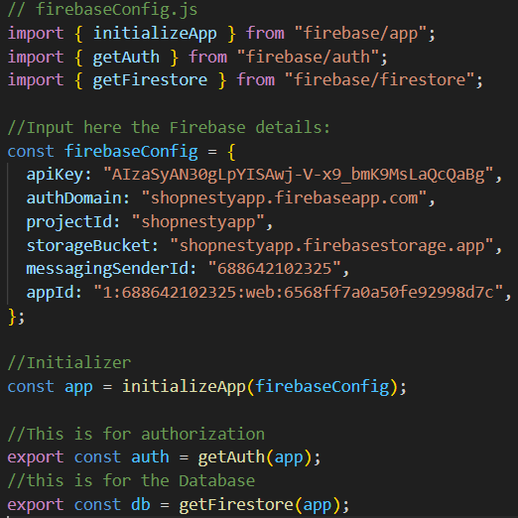

**Information**: This file is for accessing the Database of the Application, here includes the attributes of your Firebase Database to be accessed by the Application.

* const app: Initializer of the Firebase Database
* export const auth = gets the authority rules needed for accessing the database.
* Const db = this will get the Firebase Database

**Section 1.2: Firebase Authentication Services:**

Location: app/services/authservices:

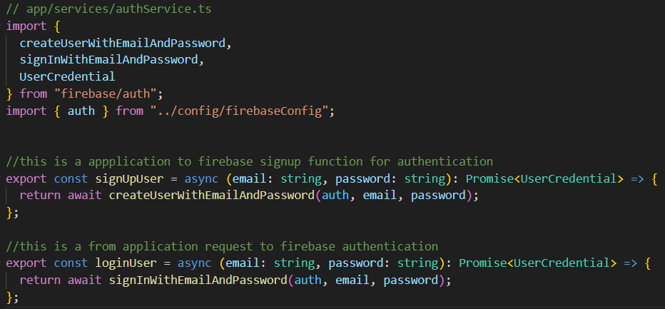

**Information:** This file handles the authentication services of the Application. It connects the frontend with Firebase Authentication and provides functions for user sign-up and log-in using email and password.

**export const signUpUser = async (email: string, password: string): Promise<UserCredential>**

**→** Function that registers a new user with Firebase using an email and password. It returns a UserCredential object that contains user details.

**export const loginUser = async (email: string, password: string): Promise<UserCredential>**

**→** Function that logs in an existing user with Firebase Authentication using email and password. It also returns a UserCredential object with authenticated user information.

**Section 1.3: Firebase User Services:**

**Location:** app/services/userServices.ts:

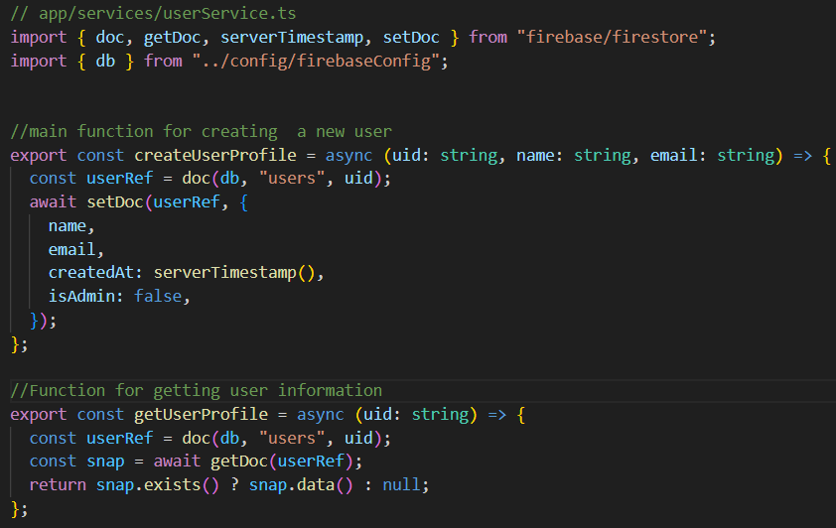

**Information**: This file handles the user services of the Application. It connects the app to Firebase Firestore Database for storing and retrieving user profile data.

**export const createUserProfile = async (uid: string, name: string, email: string)**

→ Function to create a new user profile in Firestore.

**export const getUserProfile = async (uid: string)**

→ Function to fetch user profile information from Firestore.

**Section 2.1: Authentication Functions:**

**Location:**  app/functions/authFunctions.ts:

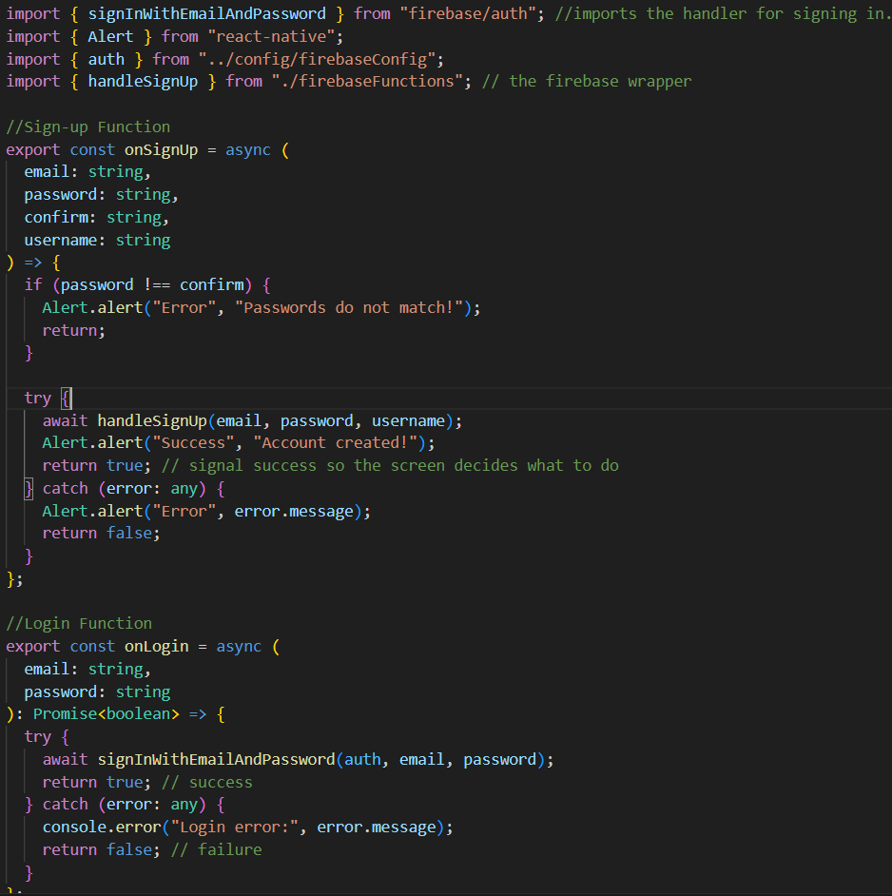

**Information:** This file manages the frontend authentication flow of the Application. It contains functions for sign-up and login with Firebase Authentication, while also providing user feedback through alerts.

**export const onSignUp = async (email, password, confirm, username)**

→ Handles the process of signing up a new user.

• Checks if password matches confirm. If not, shows an Alert error.

• Calls handleSignUp(email, password, username) to actually create the account in Firebase (and possibly Firestore).

• On success → shows a success Alert and returns true.

• On failure → shows an error Alert and returns false.

**export const onLogin = async (email, password): Promise<boolean>**

→ Handles the login process for existing users.

• Calls signInWithEmailAndPassword(auth, email, password) to authenticate with Firebase.

• On success → returns true (indicating login success).

• On failure → logs the error to console and returns false.

**Section 2.2: Firebase Functions:**

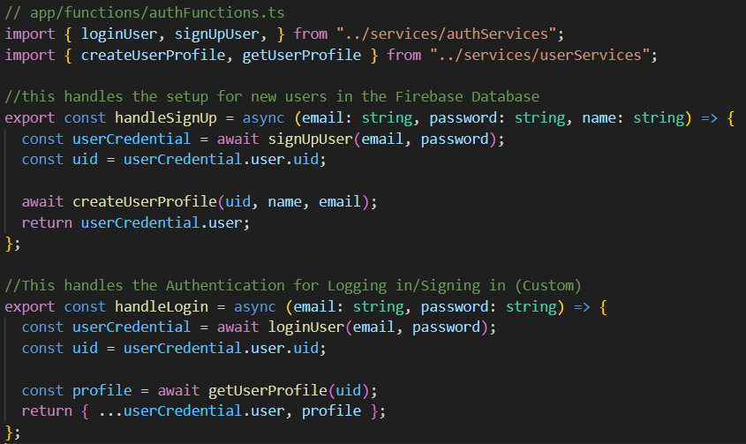

**Information:** This file acts as a bridge between authentication (authServices) and Firestore database (userServices). It defines higher-level functions that combine both user authentication and user profile management in Firebase.

**export const handleSignUp = async (email, password, name)**

**→** Handles the sign-up process and sets up a new user’s profile.

• Calls signUpUser(email, password) → creates a Firebase Authentication user.

• Extracts the uid from the returned userCredential.

• Calls createUserProfile(uid, name, email) → saves user profile details into Firestore (name, email, createdAt, isAdmin).

• Returns the created user object.

**export const handleLogin = async (email, password)**

**→** Handles the login process and fetches user profile information.

• Calls loginUser(email, password) → logs the user into Firebase Authentication.

• Extracts the uid from the returned userCredential.

• Calls getUserProfile(uid) → retrieves the user’s stored profile from Firestore.

• Returns a combined object:

Firebase Authentication’s user info (email, uid, etc.)

Firestore profile data (name, isAdmin, createdAt, etc.)